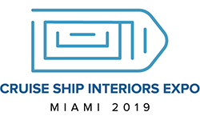

Cruise Ship Interiors Expo 2019
Sample Letter
Subject: Cruise Ship Interiors Expo Miami
Hi <First Name>,
I would like to attend Cruise Ship Interiors Expo Miami, taking place June 18-20, 2019, in Miami, FL.
Cruise Ship Interiors Expo is the world’s first event focusing exclusively on interior design, architecture, and outfitting for the cruise industry. Strategically positioned in the heart of the global cruise community, the event has attracted all the major cruise lines, shipyards, and outfitters that will be in attendance.
The conference sessions will offer insight on key industry topics that I can implement upon my return and share with other members of the team. A few of the sessions that I am particularly interested in include < Insert Session Titles >. I would like to attend these because I feel I will gain <Insert Learning Objectives > and be able to carry out the findings in <Insert Projects>.
With no delegate fee, it will only cost around <Insert Estimated Cost> for travel. I can assure you that the time and money spent away will be a long-term, worthwhile investment towards our future goals.
I will also submit a post-conference report that will include a summary of major takeaways and a list of action items for our team to implement.
Thank you for considering this request.
Regards,
<Your Name>

